The 2008 Economic Impacts of Mercedes-Benz U.S. International, Inc. on Alabama

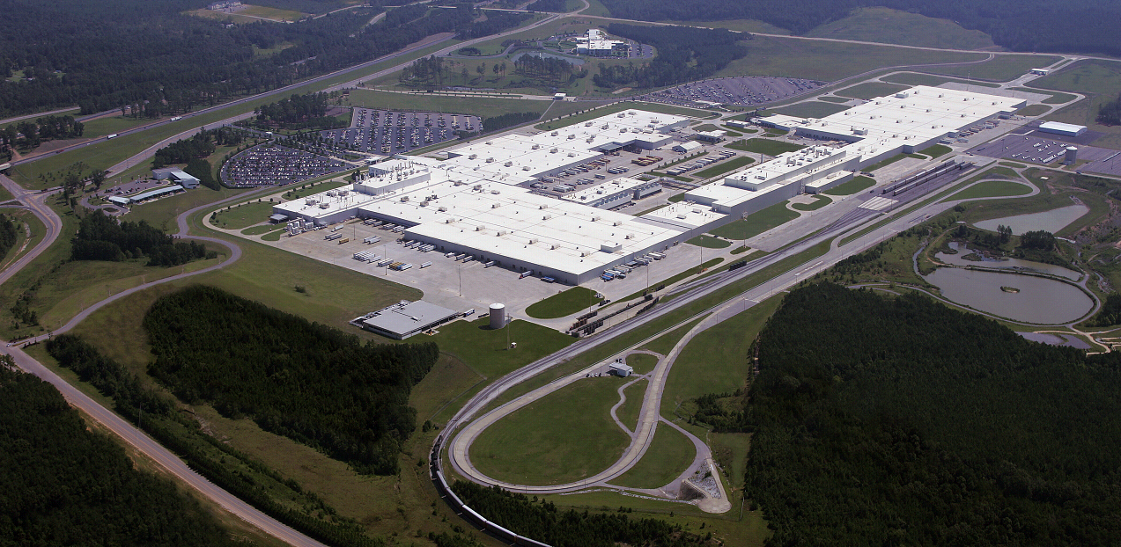

DRAFT REPORT
March 2009

Center for Business and Economic Research
Culverhouse College of Commerce and Business Administration
Executive Summary

- This report presents the 2008 economic and fiscal impacts of Mercedes-Benz U.S. International, Inc. (MBUSI) and some its suppliers on the State of Alabama and Tuscaloosa and Jefferson counties. The suppliers’ impacts are partial because data from 11 suppliers out of a reported 26 auto-related MBUSI suppliers in the state were used, with some suppliers providing incomplete data. Fiscal impacts reported are conservative because they involve income, sales, and property taxes only; other taxes and fees (e.g., utility taxes, car tags and fees, and other personal property taxes) are not included. The fiscal impacts also do not include any taxes paid directly by MBUSI and its suppliers; MBUSI paid almost $8.4 million in unabated sales and property taxes in 2008.

- MBUSI investments to date in Alabama exceed $1.0 billion. The company provides skilled, high-paying jobs; generates business for its suppliers and others; pays taxes and other impositions; advances various community and state development activities; and is the state’s largest exporter. In 2008 MBUSI employed 3,788 Alabama workers with a $243.6 million payroll for an average per employee of $64,308, which is 75 percent more than the 2007average statewide per worker earnings of $36,751. With over $1.8 billion in nonpayroll expenditures for the year, the company pumped nearly $2.1 billion into the state’s economy. The two counties accounted for 95 percent of this spending.

- The MBUSI 2008 economic and fiscal impacts on Alabama were $5.1 billion in economic activity or output, about $1.8 billion in value-added or 1.1 percent of the $165.8 billion 2007 Gross Domestic Product in Alabama (GDPAL), $826.4 million in earnings, 20,071 jobs, and $67.3 million in state ($41.8 million) and local ($25.5 million) taxes.* The company’s impacts on the two counties were for Tuscaloosa (8,126 jobs, $403.5 million in earnings, $8.1 million in sales taxes, and $2.1-3.8 million in property taxes) and for Jefferson (2,589 jobs, $137.4 million in earnings, $2.8 million sales taxes, and $1.1-2.6 million property taxes).

- From 1997 to 2008, MBUSI averaged 2,685 workers, $166.3 million payroll, and about $2.0 billion nonpayroll expenditure annually in Alabama. The cumulative $26.1 billion spending includes a nearly $2.0 billion payroll that had a collective earnings impact of $6.1 billion and generated $421.0 million in income ($200.2 million) and sales ($220.8 million) taxes; $298.3 million to state coffers and $122.6 million to counties and cities.

- Using incomplete suppliers’ data covering 1,720 Alabama workers with a $65.8 million payroll and a $163.7 million nonpayroll expenditure in the state, the partial 2008 suppliers’ impacts on the state were $560.5 million in output, $193.1 million in value-added (0.1 percent of the 2007 GDPAL), $223.2 million in earnings, 9,114 jobs, and $18.6 million in state ($11.3 million) and local ($7.3 million) taxes. Tuscaloosa County had 908 jobs, $18.8 million in earnings, $0.4 million in sales taxes, and $0.1-0.3 million in property taxes. Jefferson County had 1,473 jobs, $25.4 million in earnings, $0.5 million in sales taxes, and $0.4-0.9 million in property taxes.

- The combined full impacts of MBUSI and partial impacts of suppliers for 2008 were $5.7 billion in output, roughly $2.0 billion in value-added (1.2 percent of 2007 GDPAL), more than $1.0 billion in earnings, 29,185 jobs, and $85.9 million in state ($53.2 million) and local ($32.7 million) taxes. Tuscaloosa County had 9,034 jobs, $422.3 million in earnings, $8.5 million in sales taxes, and $2.3-4.1 million in property taxes. Jefferson County had 4,062 jobs, $162.8 million in earnings, $3.3 million in sales taxes, and $1.5-3.5 million in property taxes.

* The Regional Input-Output software, RIMS II, developed by the U.S. Department of Commerce’s Bureau of Economic Analysis was used to estimate the impacts. Local taxes are to counties and cities.

